City-wise Wellness Centre Analysis

1. Project Overview and Objective
This project focuses on cleaning, transforming, and analysing the City-wise Wellness Centres dataset using Microsoft Excel and Power BI.
The goal is to identify distribution patterns of wellness centres, evaluate doctor availability, and recommend staffing improvements through data-driven insights.

2. Data Sources
- Source Description and Timeline: Government Data/ Central Government Health Scheme/ Published On:20/12/2017
- Domain: Healthcare / Public Service Analytics

3. Problem Statement
- To analyze the distribution of wellness centres across different cities and healthcare categories.
- To identify cities with inadequate doctor availability or inactive centres.
- To predict which cities may require additional doctors or new centres in the future.
- To recommend strategies for improving staffing and operational performance of wellness centres.

4. Attribute (Column /Features) Details:
Attribute Name | Data Type | Description
City Code | String | Unique code for each city
Wellness Centre Code | String | Unique identifier for each wellness centre
Category | Categorical | Type of wellness centre (Allopathy, Homeopathy, Ayurveda, etc.)
Doctor Count | Numeric | Number of doctors available at each centre
Active Status | Categorical | Indicates whether the centre is active or inactive
Doctor Availability | Categorical | Classified as “No Doctor”, “Single Doctor”, or “Multiple Doctors”
Latitude | Numeric | Geographical latitude of the centre
Longitude | Numeric | Geographical longitude of the centre
City Name | String | Name of the city where the centre is located
Wellness Centre Number | String | Contact number of the wellness centre
Wellness Centre Address | String | Full address of the wellness centre

5. Tools & Technologies
- Excel: Data cleaning, transformation, and Pivot Tables.
- Power BI: Data modelling, DAX calculations, visualization, and interactive dashboard creation.

6. Data Pre-Processing (Excel)

Tasks Performed:
- Data Cleaning & Transformation:
Blank or missing Latitude/Longitude → replaced with correct city coordinates using IF() formulas.
Missing Wellness Centre Code → created new unique codes (e.g., D101, MU201).
Phone numbers → removed extra numbers, kept only one.
Addresses → replaced blanks with “Not Available,” shortened long ones
- Filtering & Sorting: Data was filtered by city and category to ensure accuracy and identify blank or duplicate records.
- Pivot Tables:
Used to analyze the number of centres per city and category, identify cities with higher or lower doctor availability, predict which cities may need more doctors, and recommend areas for staffing improvements
- Convert the data into Fact and Dimension Table
The dataset has been divided into 3 sheets
- Wellness Centre Fact → main measurable data
- City → unique city details
- Category → list of treatment types (Allopathy, Ayurveda, etc.)

7. Data Modelling and DAX (Power BI)
- Data Model: In Power BI, data modelling was done to connect the City and Wellness Centre and Category and Wellness Centre Table
- A relationship was created between Wellness_Center[CityCode] and City[CityCode].
- Another relationship was built between Wellness_Center[Category] and Category[Category] to filter data based on wellness centre types.
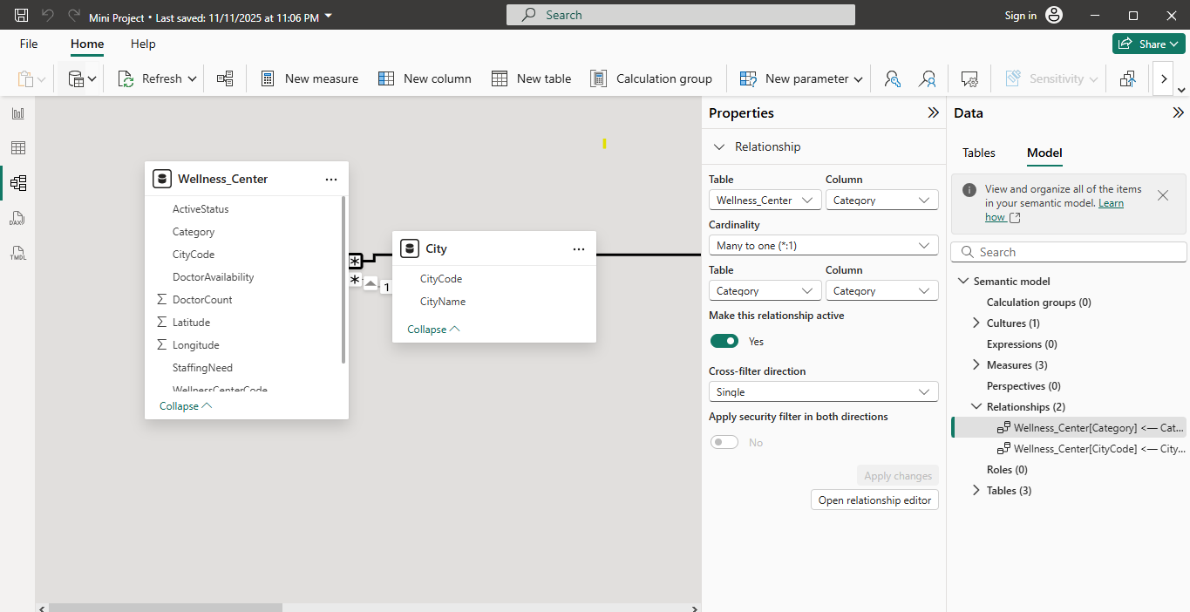
- Calculated Columns & DAX Measures: To perform data analysis and identify staffing needs.
- Average Doctor Per Centre
Calculates the average number of doctors per wellness centre for each city.
- City Needs More Doctor
Finds the city with the lowest average doctor count, indicating where more doctors are needed.
- City Need More Centre
Identifies which city needs more wellness centres based on low average doctor availability.
- These measures helped determine:
Which cities have low doctor-to-centre
Which locations need more centres or doctors, and
How staffing patterns differ across cities.

8. Analysis and Visualizations (Power BI)

Dashboard Features:
- Multiple Visualizations based on problem statement:
- Created multiple visualizations to analyze and compare wellness centre data by city.
- Used interactive elements like slicers (Category, City Name, Staffing Need) to filter data easily.
- Added cards to display key metrics such as:
- Total Wellness Centres
- Total Cities
- Average Doctor Count
- Funnel Chart – Wellness Centres by City
- 100% Stacked Bar Chart – Doctor Availability by City
- Ribbon Chart – Doctor Availability by Category
- Line Stacked Column Chart – Average Doctor Per centre
- Clustered column Chart – Staffing Need by City

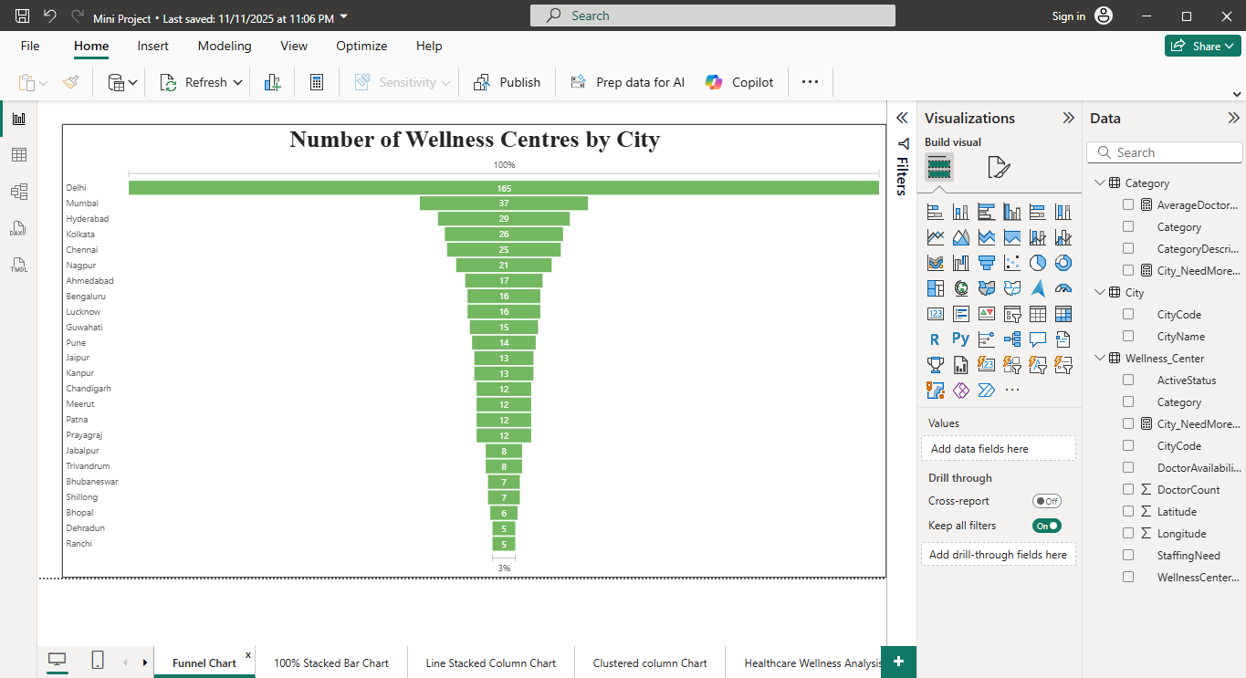
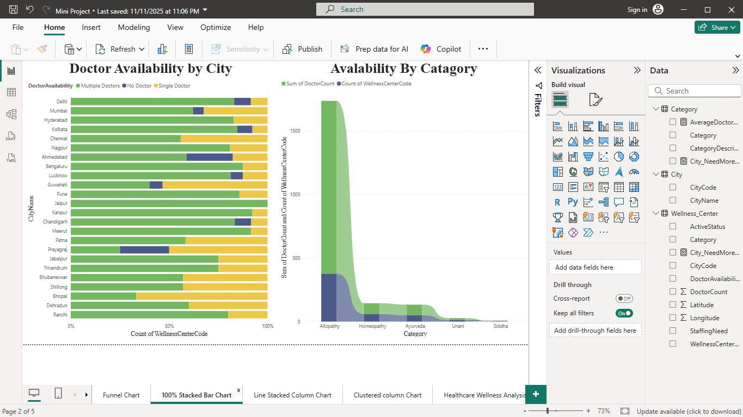

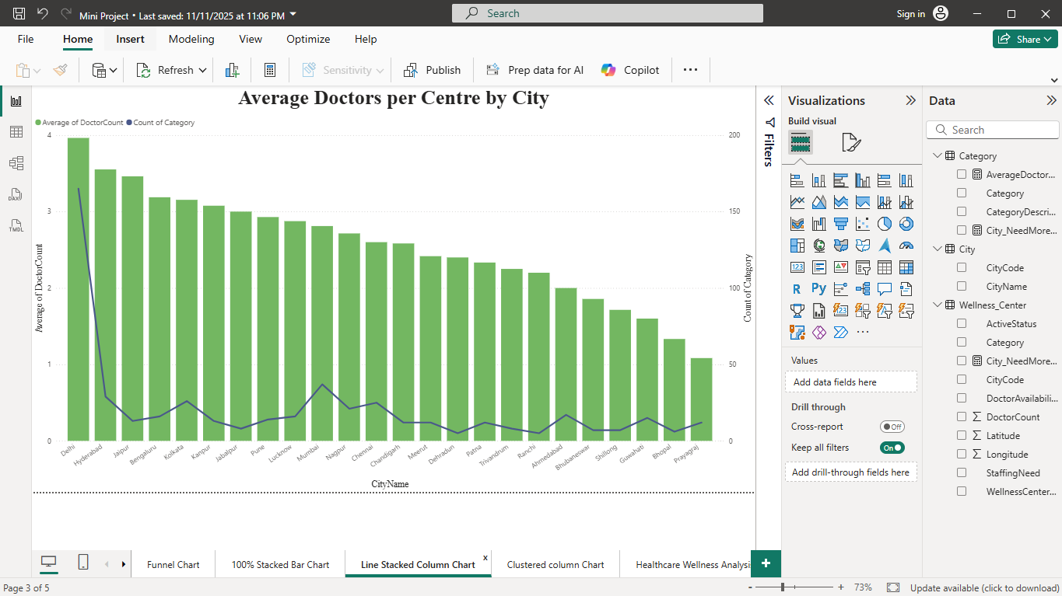

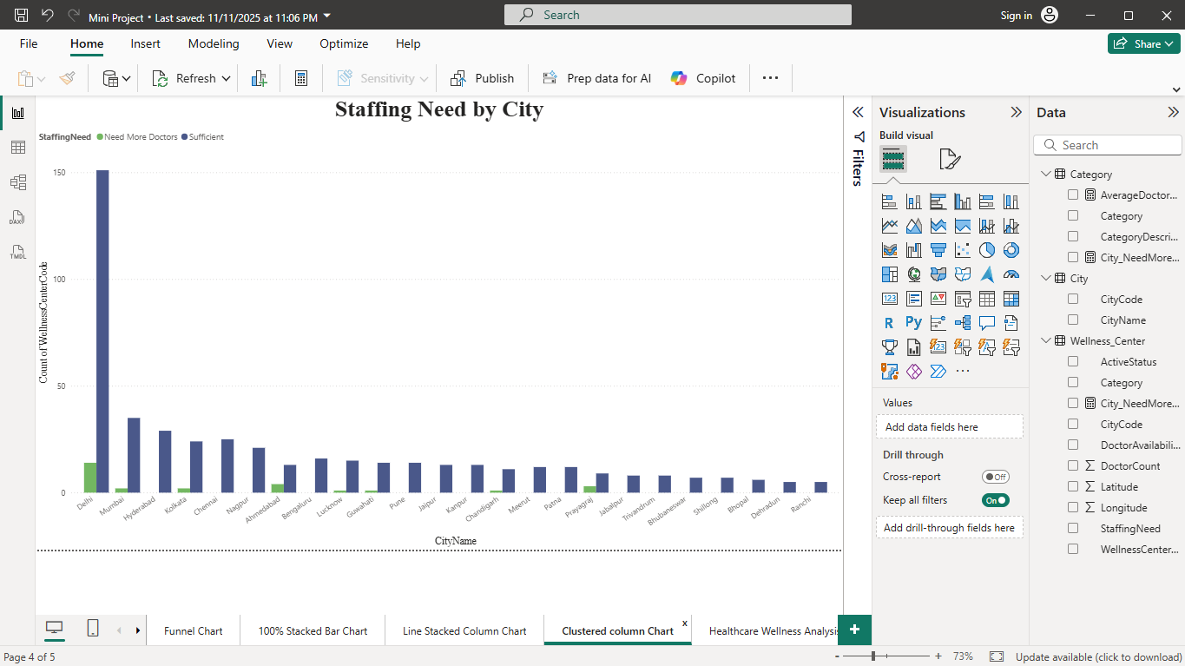

Create a consolidated Report /Dashboard.
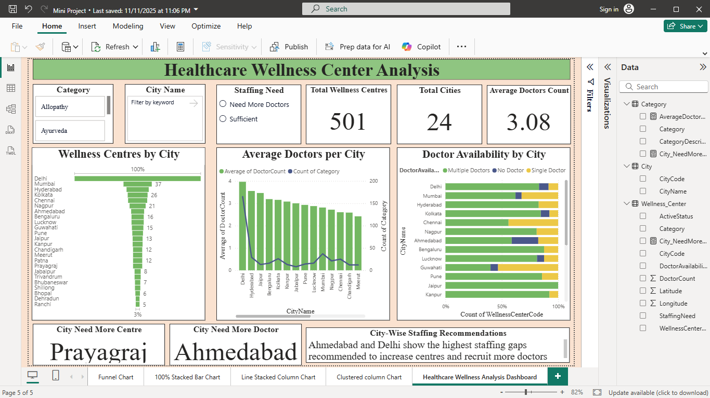

9. Insights & Conclusions
Key Findings:
In this dashboard we can understand the overall staffing and doctor availability across different cities. It helps identify which cities have enough medical support and which need improvement.
  - Major metropolitan cities exhibit strong healthcare infrastructure, whereas smaller cities display significant gaps in centre distribution.
  - Ahmedabad demonstrates the lowest average doctor availability per centre, indicating a critical need for additional medical staff.
  - Prayagraj shows insufficient wellness centre coverage, suggesting the requirement for increased facility development.
  - Several cities have a high proportion of single-doctor or no-doctor centres, highlighting inconsistencies in staffing allocation.
  - The overall analysis reveals uneven doctor-to-centre ratios across cities, emphasizing the necessity for strategic resource planning to enhance healthcare service delivery.
.
- Provide the analysis insights:
    - Descriptive:
Wellness Centres by City – shows how many centres each city has.
This analysis gives a View of the current situation.

    - Diagnosis:
Doctor Availability per City – helps understand where doctors are lacking.
Because of doctor shortages some cities may be facing performance issues.
    - Predictive:
Average Doctors per City – helps identify cities that may need more doctors.
Low average doctor count indicates that these cities may face higher workload, slow service, or shortages in the future.
    - Prescriptive:
Staffing Need by City – recommends where more staff or centres are required.
It helps to make a decision where to hire more doctor or expand service to improve overall healthcare support.
10. Conclusions
This project demonstrated a full data analysis workflow by using Microsoft Excel for data preprocessing and Power BI for creating interactive dashboards. The analysis clearly highlighted variations in wellness centre distribution, doctor availability, and staffing needs across cities. Through descriptive, diagnostic, predictive, and prescriptive insights, the dashboard identified key staffing gaps and areas requiring immediate attention.
Overall, the project provides a strong foundation for data-driven decision-making, helping organizations plan resources more effectively and improve healthcare service delivery across different cities.

